
Gateway Fund Raising Service, Inc.

The following information should be shared with the School Contact so they can access the fundraiser report dashboard.

Visit: Report.schoolshopping.org

Login ID
Password

Video Instructions https://vimeo.com/434735400

The following information should be shared with the fundraising participants (students).

Register on a Computer | Register on a Mobile Device
Register. insert your domain here .com  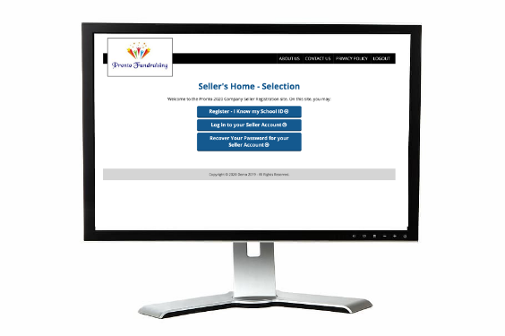 | Download MyFundR App  

School / Organization ID | SS

Video Instructions for a Mobile Device https://vimeo.com/434735273

Video Instructions for a Computer https://vimeo.com/434735155

